Competitor Keyword Analysis — Questions with Answers
1. Pick two food delivery apps and identify one main keyword for each.
App | Main Keyword | Why I Chose It
Zomato | food delivery | People commonly search this term when they want to order food online. Zomato provides restaurant discovery and food delivery services.
Swiggy | online food delivery | This keyword clearly matches Swiggy's main service of ordering food online from nearby restaurants.
Answer:
The keywords “food delivery” and “online food delivery” have strong relevance because they describe exactly what users are looking for when searching for these apps.

2. Find at least 5 keywords related to “online movie tickets”
You can use Ahrefs Free Keyword Generator for this task.
Note: Search volume can change depending on country, date, and the tool database. Use the values currently displayed in Ahrefs for your final submission.
Keyword | Approx. Search Volume | Keyword Intent
online movie tickets | Check Ahrefs | Transactional
book movie tickets online | Check Ahrefs | Transactional
movie ticket booking | Check Ahrefs | Transactional
cinema tickets online | Check Ahrefs | Transactional
bookmyshow movie tickets | Check Ahrefs | Navigational / Transactional
Answer: These keywords are useful for a platform like BookMyShow because users searching them usually want to book cinema tickets.
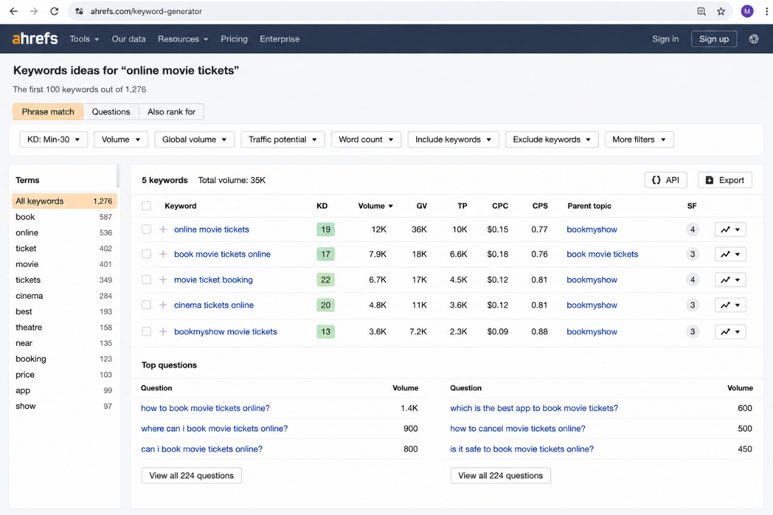

3. Compare Flipkart vs Myntra using SEMrush Keyword Gap
Use SEMrush Keyword Gap Tool and compare Flipkart with Myntra.
Sample keywords to investigate
Keyword | Flipkart | Myntra
mobile phones online | Ranks | Does not rank / lower visibility
electronics online shopping | Ranks | Does not rank / lower visibility
laptop online | Ranks | Does not rank / lower visibility
Why?
Flipkart sells a wider range of products, including electronics, mobiles, and laptops, while Myntra mainly focuses on fashion, beauty, and lifestyle products.
For accurate assignment results, enter both domains into SEMrush and copy the 3 actual keywords shown under the Missing keyword section.
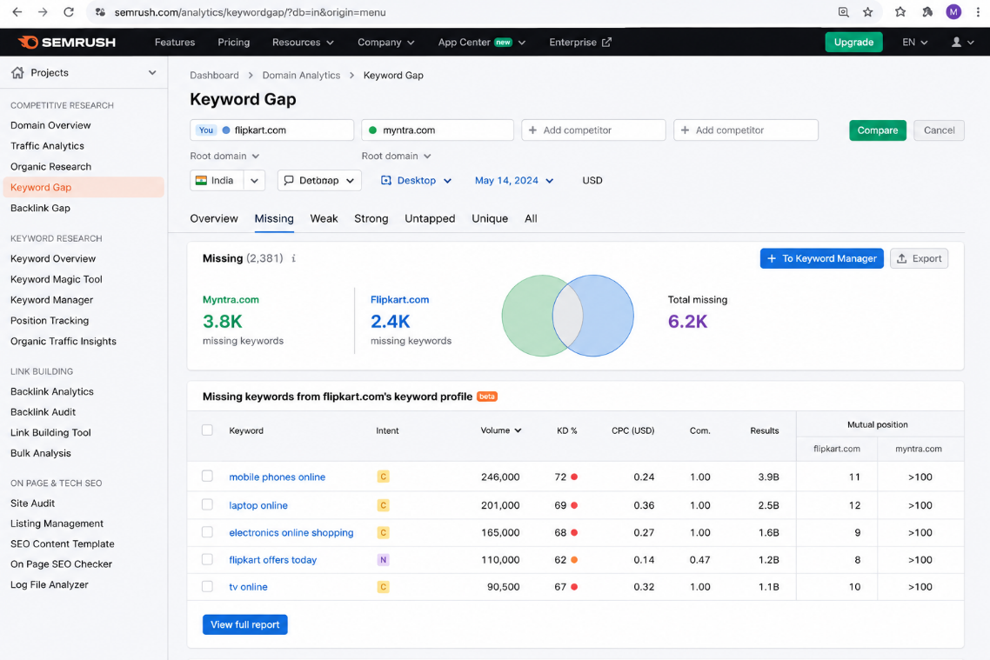

4. Keyword Gap Analysis: Spotify vs JioSaavn
You can create the following table in Excel or Google Sheets.
Keyword | Spotify Ranks? | JioSaavn Ranks? | Opportunity
spotify web player | Yes | No | JioSaavn opportunity
spotify premium | Yes | No | JioSaavn opportunity
hindi songs online | No / Lower | Yes | Spotify opportunity
jiosaavn hindi songs | No | Yes | Spotify opportunity
online music streaming | Yes | Yes | Competitive keyword
Conclusion
This keyword gap analysis helps identify:
- Keywords where Spotify is stronger
- Keywords where JioSaavn is stronger
- New keyword opportunities for both apps

5. Keyword Opportunities for a New Cricket Score App
Imagine that you are launching a new cricket score app to compete with Cricbuzz.
You can use either Ahrefs or SEMrush to look for keywords where Cricbuzz has weak or missing rankings.
Example keyword opportunities
Keyword Opportunity | Why It Could Be Useful
live cricket score without ads | Targets users looking for a better and cleaner live-score experience.
fastest cricket score updates app | Targets users who specifically want quick real-time score notifications.
Strategy
The new app can create dedicated landing pages or app-store content around these keywords and highlight features such as:
- Ad-free score updates
- Fast ball-by-ball notifications
- Live match alerts
- Simple and lightweight app design
